Presentation file - La Bête à Plumes Company

On the Other Side - De l’autre côté

Poetical circus act with objects

From 6+ - without words

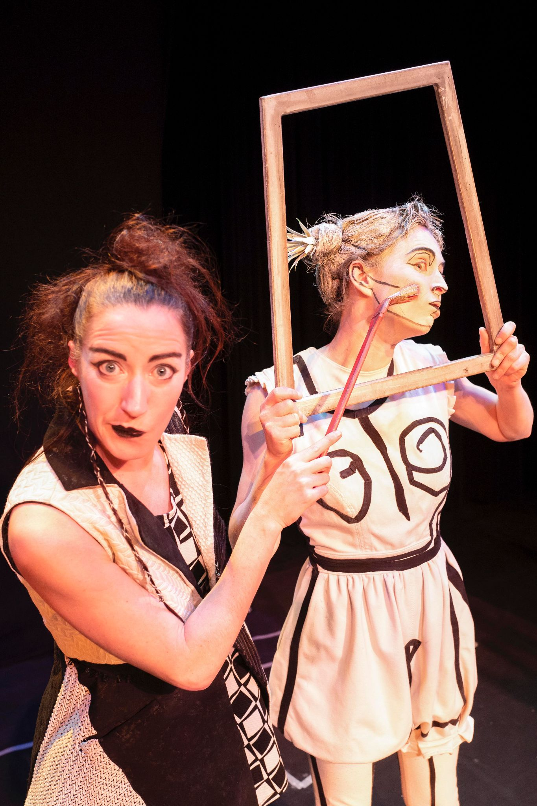
On the Other Side

A painter, looking for inspiration in front of a white canvas is travelling to the boundaries of creation. In a whirlwind where shapes and colors meet, her brushes will literally get tangled. In her spirit as much as in her workshop, the real merges magically with fantasy and brings her into a surreal looking ballet of objects.

Statement of intent

A visual artist comes home and gets ready to put the last brush strokes at her latest work but nothing seems to go right. The picture that was on the canvas goes out of her frame and brings about an unexpected encounter that will bring the artist to the boundaries of creation, a world of shapes, rhythms and colors.

The show got a mention for the mastery of the poetic writing in a circus act at the “Rencontres de Théâtre Jeune Public” in Huy (Belgium) in 2022.

Teaser : https://www.youtube.com/watch?v=li_n8MiG-UI

Presentation of the company

Website: www.labeteaplumes.com

La Bête à Plumes is a company of poetical circus acts and music that has developed since 2014 shows for all ages. The very first show of the company “Circorythm’oh” (2014), with Kevin Troussart, received the “Octaves de la Musique” prize in 2018 in the category “Jeunesses Musicales Belges’ (Youth Music). A more elaborated show in circus and theater performance will follow with “Vos Désires sont désordres" (2018). Both shows have been performed in more than 100 cultural centers and theaters in Belgium, with a total of more than 300 performances.

Isabelle Du Bois, founder of the company, started her career with a training at the International School of Theatre LASSAAD. After that she discovered juggling during her visit at the Circus School of Geneva “Théâtre Cirqule”. She deepened her knowledge at the Lido Circus School in Toulouse, where she developed an act called “Ding !”. She works with many artists such as Sylvain Pascal with whom she develops a juggling duo “CHOSES” and the show “Bernique”, a street show performance.
She specializes in working with everyday objects.

For this new creation, Andréanne Thiboutot, actress and circus artist from Montreal (Quebec), joined the company. She also followed a cursus at the International School of Theatre LASSAAD. In 2010, she created her show “ Hoopelaï”. This performance based on a comic character and the manipulation of hula hoops, toured in more than 18 countries and was performed more than 200 times.

Conception/Interpretation : Isabelle du Bois / Andréanne Thiboutot
Direction / dramaturgy / Magic conception: Andrea Fidelio
Assistant direction / Scenography : Hugues Hollenstein from «Escale» company.
Construction : La Fabrique de théâtre de Mons/David Delguste, Hugues Hollenstein, Mathieu Moerenhout
Musical creation: Mark Dehoux
Light design : Charlotte Plissart
Costume Design : France lamboray, Jeanne Sevez, Héloïse Calmet
Painting : Viviane De jonghe d’Ardoye
Stage manager : Hugues Girard
Production: Isabelle du Bois & Andréanne Thiboutot
Manager: Christine Willem-Dejean - christinedejean@mtpmemap.be - +32 (0) 497 57 97 90

